 | MINISTRY OF EDUCATION & TRAINING  HOCHIMINH CITY UNIVERSITY OF TECHNOLOGY

BASIC PROJECT

UrDoggy – A minisocial website

Discipline: INFORMATION TECHNOLOGY
Major: INFORMATION TECHNOLOGY

Supervisor: Mr. Trinh Cong Nhut
Student’s name :
- Phạm Viết Phước Student’s ID: 2280602510 Class: 22DTHQA1
- Bùi Văn Dũng Student’s ID: 2280618955 Class: 22DTHQB3
- Đào Phương Vũ Student’s ID: 2280603722 Class: 22DTHQB1

Ho Chi Minh City, 2025

Acknowledgement
First of all, we would like to sincerely thank Mr. Trịnh Công Nhựt, our instructor, for his dedicated guidance and support throughout the process of completing this project. Thanks to his instructions, we had the opportunity to develop our ideas and gain knowledge in system analysis and design. Moreover, his guidance has given us more than just technical knowledge—it has allowed us to improve our practical skills and teamwork abilities, providing real-world experiences that textbooks alone cannot offer.
During the development process, we faced many challenges and difficulties due to our lack of real-world working experience. However, thanks to his patience, valuable feedback, and continuous encouragement, we were able to overcome these obstacles.
Finally, we would like to express our deepest appreciation for all the support from our lecturer, and we hope to receive further guidance in the future as we continue learning and improving.
Thank you very much.
Ho Chi Minh city, July 15th, 2025.
People wrote this report.
Bùi Văn Dũng
Phạm Viết Phước
Đào Phương Vũ

Table of contents

Acknowledgement 1
Table of contents 1
List of Tables 4
List of Figures and Graphs 4
Chapter 1: Overview 5
1.1. Overview of the project 7
1.2. Project Objectives 7
1.3. Project Structure 8
Chapter 2: Theoretical Background 9
2.1. M.V.C (Model-View-Controller) 9
2.1.1. Definition 9
2.1.2. Components of M.V.C 9
2.1.3. Activity Stream 9
2.1.4. Reason and Compare 10
2.1.5. Deployment in Project 11
2.2. Layer Architecture 11
2.2.1. Definition 11
2.2.2. Key Layers 11
2.2.3. Dependencies 13
2.2.4. Reason and Compare 13
2.2.5. Deployment in Project 13
2.3. ASP.NET 14
2.3.1. Definition 14
2.3.2. Outstanding features 15
2.3.3. Role in the project 15
2.3.4. Reason and Compare 15
2.4. SQL Server & SSMS 16
2.4.1. Introduction 16
2.4.2. Advancement Features 17
2.4.3. Comparison 18
2.4.4. Database diagram and data tables detail 19
2.5. StarUML 23
2.5.1. Introduction 23
2.5.2. Advancement features 24
2.5.3. Comparison 24
2.5.4. Use Case Diagram 25
Chapter 3: Experimental Results 26
3.1. Authentication 28
3.1.1. Login feature 28
3.1.2. Register feature 29
3.2. Main page / Homepage 29
3.2.1. Newsfeed 29
3.2.2. Create post 31
3.2.3. Post edit/delete 32
3.3. Post interact 32
3.3.1. Voting feature 32
3.3.3. Edit / delete comment 33
3.4. Sharing feature 33
3.5. Report feature 34
3.6. Hide / unhide post feature 34
3.6.1. Hide post 34
3.6.2. Unhide post 35
3.7. Profile and Friends 36
3.7.1. View profile 36
3.7.2. Edit profile 37
3.7.3. Friend actions 37
3.8. Search feature 39
3.9. Messaging 39
3.10. Notification 41
3.11. Admin dashboard 42
Chapter 4: Conclusion and Recommendations 43
4.1. Conclusion 43
4.2 New proposals and recommendations 43
REFERENCES 44

List of Tables

Table 1: Comparison between SQL Server & SSMS with other solutions. 18

Table 2: Users table detail. 20

Table 3: Posts table detail. 20

Table 4: Comments table detail. 21

Table 5: PostVotes table detail. 21

Table 6: Friends table detail. 21

Table 7: Reports table detail. 22

Table 8: Messages table detail. 22

Table 9: Notifications table detail. 23

Table 10: Compare between StarUML and other tools. 25

Table 11: Feature table 28

List of Figures

Image 1: MVC design pattern 10

Image 2: Layer Architecture 12

Image 3: ASP.NET logo 14

Image 4: SQL Server logo. 16

Image 5: SSMS logo. 17

Image 6: Database diagram. 19

Image 7: StarUML logo. 23

Image 8: Use case diagram. 25

Image 9: Login page 28

Image 10: Register page. 29

Image 11: Newsfeed 29

Image 12: Topbar 30

Image 13: General user’s left sidebar 30

Image 14: Admin’s left sidebar 30

Image 15: Right sidebar when user don’t have friend yet 30

Image 16: Right sidebar when user have friend(s) 31

Image 17: Creating new post with image Url 31

Image 18: After click post 31

Image 19: Post view if user’s post 32

Image 20: Post view from other users 32

Image 21: Up / down vote 32

Image 22: Comment box on each post 33

Image 23: After comment 33

Image 24: When user want to edit or delete. 33

Image 25: Share button 33

Image 26: After click share button 34

Image 27: Report button 34

Image 28: Report form (Allows moderation without admin access.) 34

Image 29: Hide and unhide button 34

Image 30: Before hide post 34

Image 31: Post now being hidden 35

Image 32: Unhide post from user’s profile 35

Image 33: After unhide post 35

Image 34: Own user’s profile 36

Image 35: Other’s profile 36

Image 36: Edit profile form 37

Image 37: After changed avatar and bio. 37

Image 38: “Friends” button on left sidebar 37

Image 39: “Add friends” button on right side bar 37

Image 40: If user have no friend yet 38

Image 41: If user have friend 38

Image 42: When have no another user request 38

Image 43: When have another user request 38

Image 44: New Friends session 38

Image 45: If user search for themself 39

Image 46: If user search for others 39

Image 47: Message button on navbar 39

Image 48: Message button on other user’s profile 40

Image 49: Message page 40

Image 50: Message page when other reply 41

Image 51: Bell icon - notification button 41

Image 52: Notification page 41

Image 53: Admin dashboard display all users 42

Image 54: Admin dashboard display all post 42

Image 55: Admin dashboard display all report 42

Chapter 1: Overview

1.1. Overview of the project
In today's digital age, social networks have become a trend to connect people. They share information to build a community where people can share with each other without having to meet in person. With the goal of providing people with space and an environment to connect with each other, this project focuses on building a social networking website.
This project provides basic features for people to interact with each other, including posting, commenting, liking posts, messaging, making friends, viewing profiles, and many other features. Users can easily use it to interact and connect with others on the platform. The website interface is beautifully designed, user-friendly, easy to use, and easy to access.
The project focuses on researching existing social networking systems. Analyze how to manage posts, users, and relationships between users. The project uses ASP.NET Core to develop applications. In addition, the project uses Layer Architecture and the M.V.C model to separate systems for easy maintenance and development.

1.2. Project Objectives
The need to connect and interact with relatives or new people has become a normal thing in today's society, but there are always limitations, such as having to go out and meet in person, difficulty finding a community or group that suits you. These things make us waste time and have difficulty finding new people who suit us. With the strong development of current technology, the need to connect with people online is increasing. From the needs on social networking websites were born so that users can share, find communities, and interact with people far away. The project was created with the purpose of applying modern models and architectures to develop optimal social networking applications that have the ability to develop in the long term.
Scientific significance: The project is an opportunity to research and develop practical applications using modern structures and models.
Practical significance: Creating a social networking platform that allows users to interact, share, and connect with the community.
The research objective of this project is to develop an application using the M.V.C model and Layered Architecture in the ASP.NET Core platform. Build an application that can manage users, user profiles, friendship relationships, and features related to sharing and connecting, such as posting, commenting, and messaging.
The target audience of this project is users and system administrators.
The scope of the project includes basic features on social networking platforms. The project will not include advanced features such as advertising or complex algorithms, such as article recommendations.

1.3. Project Structure
The report includes 4 main chapters.
Chapter 1. Overview: Introduction to the topic, urgency, reason for formation, project objectives, subjects, scope, and structure of the topic.
Chapter 2. Theoretical Background: Presents in detail the theories and architectural models used in the project, including Layer Architecture, M.V.C, Database, UML, Package, and ASP.NET.
Chapter 3. Experimental Results: How the project was built and the results after completion.
Chapter 4. Conclusion and Recommendations: Final conclusion about the project and proposed plan for developing this project in the future.

Chapter 2: Theoretical Background

2.1. M.V.C (Model-View-Controller)

2.1.1. Definition
MVC or Model-View-Controller is a software design pattern. As its name suggests, this design pattern consists of 3 parts: Model, View, and Controller. The strength of this pattern is that it separates 3 separate parts to handle different tasks and functions in the application. This helps us to program the application without fear of the parts conflicting with each other during the application development process.

2.1.2. Components of M.V.C
The components of M.V.C include 3 main components: Model, View, Controller.
Model is where the application interacts and processes data-related tasks. Features such as reading, updating, adding, and deleting data will all go through the Model. The Model will contain code or functions that directly query the data. For example, if the application wants to add a user's information, the application will use the Model to add a new row of data.
View is the part that displays the user interface of the application. This is where the front-end code of the application will be contained. The interfaces that will be displayed for users to see and interact with will be handled by View. Normally, a View will be created based on a Model.
Controller is the part between View and Model. The controller is considered the brain of the application. The controller is used to interact with and process user requests. Controller relies on requests to call functions to interact with data in the Model and send results to the View to display to users. The controller will be considered the Back-End in the application.

2.1.3. Activity Stream
The processing flow in MVC includes the following steps: First, the user sends a request by interacting with the View, then the View sends the user's request to the Controller. Next, the Controller will receive the request from the View and begin to analyze and process the request. If it is a request that can be processed without interacting with data, the Controller will process it, but if it involves interacting with data, the Controller will send the request to the Model for processing. The Model will receive the request to interact with the Controller's data and process it. After processing, the Model will send the processing result to the Controller. Finally, the Controller will send the processing result to the View, and the View will display that result.
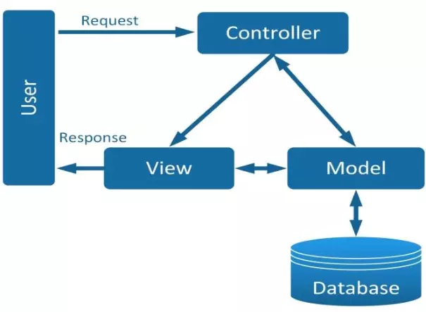
- MVC design pattern

2.1.4. Reason and Compare
Apart from MVC, there are other patterns like MVP (Model-View-Presenter) which also have separation. MVP is different from MVC; MVP separates View and Logic in the background, not linked like MVC. This makes testing easier but requires more code. Each structural pattern has its own strengths and weaknesses, but in this project, MVC is the most commonly used pattern in ASP.NET. ASP.NET is the framework used in this project. Not only that, for a simple project like this, using a simple and easy-to-use pattern is a good choice.

2.1.5. Deployment in Project
M.V.C in this project aims to separate, manage the interface, and the logic behind it. The logic code will be written in the Controller, and the interface code will be written in the View. But in this project, the Model does not store data as usual, but will store a ViewModel data specifically for 1 View. The reason the Model does not store data is that it is stored somewhere else, specifically another project called "Core"; this is the Core layer from the Layered Architecture (more details in 2.2. Layer Architecture). The project will use the Controller to handle the logic, the View to handle the interface, and the data will be applied to the Layered Architecture for better processing and management.

2.2. Layer Architecture

2.2.1. Definition
Layered architecture is an application development architecture. This is an architecture that divides the application into different layers that are stacked on top of each other. Usually, the flow of activities will be executed from top to bottom, and each layer will have the task of receiving requests from the layer above and interacting with the layer below it to process the request. Each layer has different tasks in the application and is built independently of the other. This helps developers build applications more easily.

2.2.2. Key Layers
In Layer Architecture, there can be many layers, and this depends on the application developer, but usually this architecture includes 4 main Layers: Presentation, Application, Persistence, Database.
Presentation Layer is the layer that stores the user interface used to interact with the user. This layer is usually placed at the top to get the user's request when they interact with the interface, and will pass the request down to the Layer below it. After the Layers below successfully process the data, they will return the result to the Presentation layer to display the result to the user.
Application Layer is the layer that processes user requests. The application is usually placed below the Presentation. This layer will receive user request information from the Presentation layer and process it. If the request is not related, does not need to interact with data, this layer will process it and return the result to the layer above. If it is necessary to use database-related tasks, this layer will send the request to the layer below it for processing. After the layers below have finished processing, the Application layer will receive the processing results and push those results to the Presentation layer.
Persistence layer is the layer that interacts with the database layer. The Persistence layer can be placed below the Application layer to receive and process requests to interact with the database coming from the Application layer. This layer will send the processing request down to the Database Layer to interact with the database. After success, it will send the result up to the Application layer above.
Database Layer is the layer that directly interacts with the database. The layer is used to directly query the database. The Database layer provides code to add, delete, edit, and read the database. This layer is usually placed below the Persistence layer to receive database interaction requests and process them. After processing, it will return to the Persistence layer above.
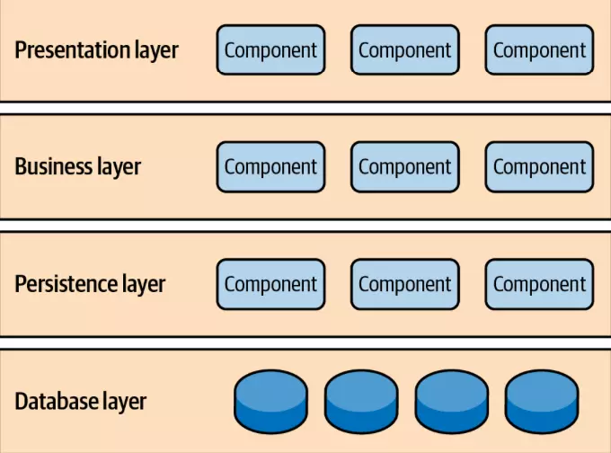
- Layer Architecture

2.2.3. Dependencies
The layers in the Layer Architecture have rules that only receive requests from the layer above and send processing requests to the layer below. This is the dependency of each layer in the structure to ensure a separate, independent relationship with the other. For example, the Presentation Layer only sends requests and receives output from the Application Layer. Separating the layers like this will help developers develop each part without fear of code conflicts with each other during the application development process.
The flow of this structure usually starts with the user interacting with the application. The user's request will be received by the Presentation Layer and sent to the layer below, the Application Layer. The Application Layer will receive the request and process it. If the request does not need to interact with data, the Application Layer will process it and return the result to the Presentation Layer immediately. But in the case of needing to interact with data, the Application Layer will send this request to the layer below, the Persistence layer. The Persistence layer will receive the processing request and send this request down to the Database Layer to interact with the system database. After processing, the Persistence layer will send the result to the Application Layer, and the Application Layer will send it to the Presentation Layer to display the result to the user.

2.2.4. Reason and Compare
In addition to Layer Architecture, we have many other architectures, such as Monolithic Architecture. Monolithic Architecture is an architecture that combines everything into a single block. This architecture is simple and is often used in small projects, but if used in larger projects, it will be very difficult to manage and develop applications later. In the case of this current project, it can be considered a small project, but this project will be developed later, so Layer Architecture will be a better choice.

2.2.5. Deployment in Project
This project will include 4 main layers: Core, Data, Services, and Web. The Core layer will hold the data storage models of the website. The Data layer will store the operations of adding, deleting, editing, and reading directly to the data. The Services layer is the layer that uses the features from the Data layer. The Web layer includes the interface and processing logic and uses the M.V.C model for management. According to Layered Architecture, the layers will overlap, and the processing requests will go from top to bottom and then up. The first layer to receive user requests is the Web layer. User requests will be sent through the interface of this layer. Then the Web layer will process that request and send it to the layer below, the Services layer. The Services layer will process and call the features of the Data layer, so the request will be transferred to the Data layer. The Data layer will use the Core layer as the data storage to manipulate the data. After the Data layer finishes processing, the Services layer will receive the result and send it to the Web layer. Finally, the Web layer takes that result and displays it to the user through the interface.

2.3. ASP.NET

2.3.1. Definition
ASP.NET is a framework from Microsoft that helps developers build web applications. ASP.NET supports many programming languages such as C#, VB.NET, and F#. Not only that, ASP.NET is also compatible with many different operating systems such as Windows, Linux, and macOS. This framework provides developers with many powerful libraries to support them in building applications.


- ASP.NET logo

2.3.2. Outstanding features
ASP.NET has high performance that helps optimize the responsiveness of the application. ASP.NET is constantly updated to make the framework more and more powerful, especially with the latest version is ASP.NET Core. This framework also supports multiple operating systems such as Windows, Linux, and macOS, and is also open source, which creates conditions for a strong development community. ASP.NET has the ability to integrate and use other ecosystems, such as other .NET libraries, tools, and the Entity Framework to manage databases. ASP.NET also strongly supports the M.V.C model. This helps the framework support project management, source code organization, and projects better.

2.3.3. Role in the project
In this project, ASP.NET plays the role of the main project building framework. Using the M.V.C model to build and manage the interface and back-end logic of the website application. Integrating external interface libraries to make the front-end website. ASP.NET also supports interactive connection with the database.

2.3.4. Reason and Compare
Except for ASP.NET, PHP is also a popular programming language used in website programming. PHP is similar to ASP.NET in that both languages ​​can operate on multiple platforms, such as Windows, Linux, and macOS, and have a large community. PHP supports many types of databases and libraries to support developers in the application-building process. But PHP is often used to develop small applications and requires fewer resources than ASP.NET. In this case, a project is small but can grow stronger and bigger in the future, so ASP.NET is a better choice in this case.

2.4. SQL Server & SSMS

2.4.1. Introduction
SQL Server is a Relational Database Management System (RDBMS) developed by Microsoft. It is used to store, manage, and retrieve data upon request from applications. SQL Server allows developers to perform various operations such as Insert, Update, Delete, Find, and Select using SQL (Structured Query Language). It also provides tools for data analysis, reporting, and security management to ensure data integrity and safety.


- SQL Server logo.
In this project—a Mini Social Network System—SQL Server is used as the primary data storage solution. It stores all critical data, including: User Accounts, Posts and Comments, Messages between users, Reports and Report Descriptions, Admin Activity Logs, etc.
Due to the small scope of this project and the need for rapid development, our team chose not to use all relational database features such as foreign key constraints or enforced relationships between tables. Instead, we use SQL Server primarily for data storage, while the application layer manages relationships. This approach increases development flexibility and reduces complexity during the early stages of the project. It also allows for faster testing and simpler database migrations while the project is still small and evolving.
To interact with SQL Server more conveniently during development, we also use SQL Server Management Studio (SSMS). SSMS provides a graphical interface for developers to manage databases easily. Using SSMS, we can: Create and design databases and tables; Run SQL queries directly; Perform CRUD operations (Create, Read, Update, Delete).
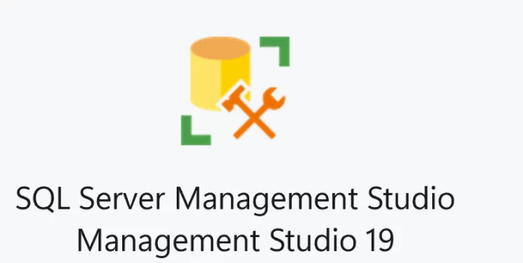
- SSMS logo.

In our project, SSMS plays a crucial role by helping the team visualize data structures, test queries, inspect records, and manage the database effectively without relying solely on command-line tools.

2.4.2. Advancement Features
SQL Server provides a high performance - a result of using many optimizations: intelligent query optimization, in-memory technology, parallel execution and advanced indexing with modern hardware support. In addition, SQL Server is continuously improved and updated by Microsoft to enhance its performance and capabilities. SQL Server can support cross-platform deployment - an important field that our project, a mini social network, needs to be considered for the opportunities in the future - including Windows and Linux using Docker Container. Although SQL Server is a proprietary product, it has a large development community, rich documents and extensive support by Microsoft which make it easier for the learning and troubleshooting process.
SQL Server integrate very well with ASP..NET especially with the latest version is ASP.NET Core - with same development company, SQL Server is designed to fit perfectly with ASP.NET through using Entity Framework Core; it also have many provider by Microsoft like LINQ, Miration, … and easily for configuration and many more advancement especially SSMS support tool make it become an perfect component

2.4.3. Comparison
After doing some research about SQL Server & SSMS and other solutions for our project, we concluded that SQL Server & SSMS is the best solution for our project. It provides a balance between performance, integration, ease of use and future scalability (an important criteria because we want to evolve this project in the Advance project). With these solutions, it will allow us to focus more on the building application features rather than dealing with database complexity in the early stages, while still ensuring we have room to grow our project in future.

Criteria | SQL Server + SSMS | Other Solutions (MySQL, PostgerSQL, etc.)
Integration with ASP.NET Core | Excellent. Fully supported via EF Core, LINQ, etc. | Good, but usually requires third-party provider or extra setup
Performance | Optimized for Windows and .NET ecosystem; strong transaction support | Good, but might lack deep optimization for .NET apps.
Management Tool | SSMS: Rich GUI, easy to use and support all operations (CRUD, etc.) | phpMyAdmin/ pgAdmin, not as tightly integrated
Documentation & Support | Extensive documentation, large community, Microsoft support directly | Large community, but enterprise - level support.
- Comparison between SQL Server & SSMS with other solutions.

2.4.4. Database diagram and data tables detail
- Database diagram
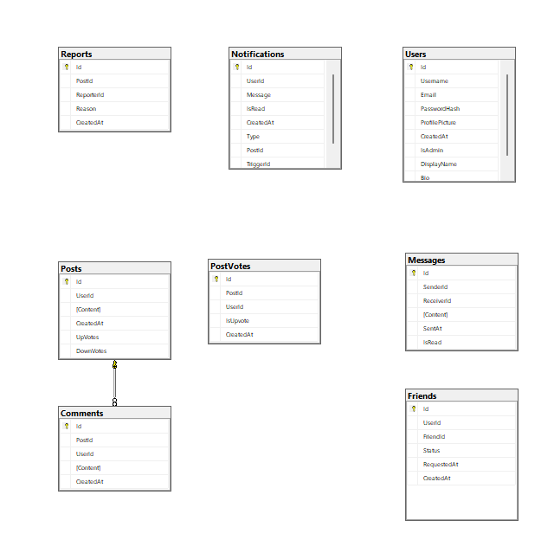
- Database diagram.

- Users table
No. | Attribute | Data type | Meaning | Constraint
1 | Id | int | Id of users | Identity
2 | Username | nvarchar(50) | Username | Not null, Unique
3 | Email | nvarchar(100) | Email of user | Not null, Unique
4 | PasswordHash | nvarchar(255) | Password of the user | Not Null
5 | ProfilePicture | nvarchar(255) | Profile picture path
6 | CreatedAt | Datetime | When account create | Default
7 | IsAdmin | BIT | Check if it’s an admin | Default = 0
8 | DisplayName | nvarchar(100) | The name represent | Null
9 | Bio | nvarchar(500) | Introduce about user | Null
- Users table detail.
- Posts table
No. | Attribute | Data type | Meaning | Constraint
1 | Id | int | Id of post | Identity
2 | UserId | int | UserId
3 | Content | nvarchar(max) | Content of post
4 | CreatedAt | Datetime | When post create | Default
5 | UpVotes | int | Number of user like | Default = 0
6 | DownVotes | int | Number of user dislike | Default = 0
- Posts table detail.

- Comments table
No. | Attribute | Data type | Meaning | Constraint
1 | Id | int | Id of comment | Identity
2 | UserId | int | User Id
3 | PostId | int | Post Id
4 | Content | nvarchar(max) | Content of comment
5 | CreatedAt | Datetime | When comment create | Default
- Comments table detail.
- PostVotes table
No. | Attribute | Data type | Meaning | Constraint
1 | Id | int | Id of the vote | Identity
2 | UserId | int | User Id
3 | PostId | int | Post Id
4 | IsUpvote | bit | Upvote or Downvote
5 | CreatedAt | Datetime | When user vote | Default
- PostVotes table detail.

- Friends table
No. | Attribute | Data type | Meaning | Constraint
1 | Id | int | Id of the friend | Identity
2 | UserId | int | User Id
3 | FriendId | int | The other user id
4 | Status | nvarchar(20) | Status of the friendship
5 | RequestAt | DateTime | When user send request
6 | CreatedAt | Datetime | When relationship create | Not null, Default
- Friends table detail.

- Reports table
No. | Attribute | Data type | Meaning | Constraint
1 | Id | int | Id of the report | Identity
2 | UserId | int | Id of the user is reported
3 | ReporterId | int | Id of the user report
4 | Reason | nvarchar(255) | Reason user report
5 | CreatedAt | Datetime | When report create | Not null, Default
- Reports table detail.

- Messages table
No. | Attribute | Data type | Meaning | Constraint
1 | Id | int | Id of the message | Identity
2 | SenderId | int | Id of the sender
3 | ReceiverId | int | Id of the receiver
4 | Content | nvarchar(max) | Content of the message
5 | SenAt | Datetime | When the message is send | Default
6 | IsRead | bit | Is the message been read | Default = 0
- Messages table detail.

- Notifications table
No. | Attribute | Data type | Meaning | Constraint
1 | Id | int | Id of the notification | Identity
2 | UserId | int | Id of the user
3 | Message | nvarchar(255) | Content of notification
4 | IsRead | bit | State of the notification | Default = 0
5 | CreatedAt | Datetime | When notification create | Default
6 | Type | int | Type of the notification | Not Null
7 | PostId | int | Id of the post | Null
8 | TriggerId | int | Id of the activity | Null
- Notifications table detail.

2.5. StarUML

2.5.1. Introduction
StarUML is a software modeling tool used widely by the developers for system analysis and design purposes. It support various modeling standards such as UML - Unified Modeling Language, ERD - Entity Relationship Diagram - and Flowcharts, making it become an popular solution for both academic and professional software development projects.

- StarUML logo.

In our project - a mini social network system - StarUML is used for designing the system architecture, we use the application to create a Use Case Diagram. By visualizing the structure and interactions of the system, StarUML helps us to define the relationships between components, clarify requirements, and plan development logically.
With the small scope of this project and the need for rapid development, it allows our team to quickly prototype designs without enforcing strict formal validation. This gives us flexibility to adjust models during the evolving stages of development while still maintaining a clear structure.

2.5.2. Advancement features
StarUML provides many powerful features that support the needs of developers like: Code Generation, Multi-diagram support, … and the most importantly StarUML is continuously updated by its development team to improve performance, usability and compatibility with modern technologies. One of StarUML's key advantages is cross-platform support, running smoothly on Windows, macOS, and Linux. This makes it accessible to diverse development environments, a feature that aligns well with the future needs of our project. Although StarUML is proprietary software, it offers: an intuitive interface, large user community, rich documentation and active support forums. With these advancement, this solution allows us to apply our knowledge into real-life challenges and a chance to grow our knowledge.

2.5.3. Comparison
After researching StarUML and comparing it with other solutions, we concluded that StarUML is the best solution for our project. It provides our team a balance of Ease of use, Cross-platform support, Comprehensive modeling features and Extensibility for the future needs. By choosing it, our team can focus more on designing and visualizing system requirements instead of dealing with the complexity of coding or technical setup during the early development phase. At the same time, it provides a scalable foundation for future improvements and documentation.

Criteria | StarUML | Other solutions (Visual Paradigm, Lucidchart, etc.)
Ease of use | Simple, intuitive interface; quick learning curve | Can be complex or require an training step to use it
Cross-platform support | Fully supports Windows, macOS, Linux | Some tools are web-based or OS-dependent
Community & Support | Large community, extensive documentation, active plugin ecosystem.. | Varies depending on the tool
Multi-Diagram support | Support UML, ERD, Flowcharts and extensions | Usually specialized in specific diagram types.
- Compare between StarUML and other tools.

2.5.4. Use Case Diagram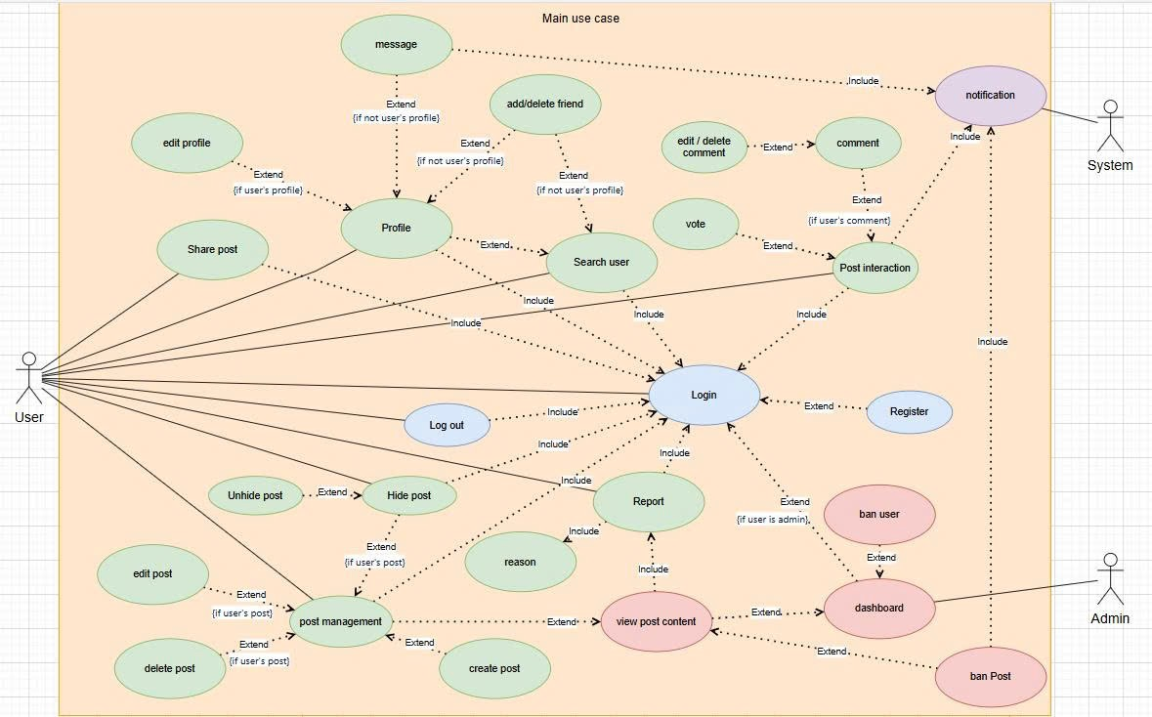
- Use case diagram.

Chapter 3: Experimental Results
No. | Category | Feature | Description | Access location
1 | Authentication | Login / Register | Secure account creation and session management | When ever open the app
2 | Main page | Newsfeed | Displays posts from all users with interaction buttons | After login successful / home icon / logo button
 |  | Create Post | Add a post with optional media upload | Newsfeed form
 |  | Edit/Delete Post | Manage own posts from newsfeed | Inline controls
 |  | Post Detail View | Expanded view of individual post and its comments | On each post
3 | Interaction | Voting | Upvote or downvote a post | Newsfeed and Detail views
 |  | Commenting | Add a comment to a post | Below each post
 |  | Edit / Delete Comment | Inline form for managing own comments | Newsfeed and Detail views
4 | Sharing | Share link | Copy direct URL to post detail into clipboard | All post locations
5 | Reporting | Report Post | Submit a reason for flagging a post | Report button
6 | Category | Feature | Description | Access location
7 | Hiding | Hide / Unhide Post | Customize feed visibility | Newsfeed actions
8 | Profiles and Friends | View Own or Others's Profile | Display user info, posts, and friendship status | Profile button / click on any user that want to view profile
 |  | Edit Profile | Update avatar, display name, and bio | User profile detail
 |  | Friendship Actions | Add, respond to, or remove connections | User profile detail
9 | Search | Search Users | Find users by keyword and send friend requests | Search bar on top of newsfeed page
10 | Messaging | Send/Receive Messages | Chat privately with friends | Profile, Inbox
11 | Notifications | Activity Alerts | Updates about votes, replies, requests | Bell icon
12 | Admin Dashboard | Post Moderation / User Reports | Admin tools for content review, account banning, and analytics | If current user account is admin, dashboard button on the left sidebar
- Feature table

3.1. Authentication

3.1.1. Login feature
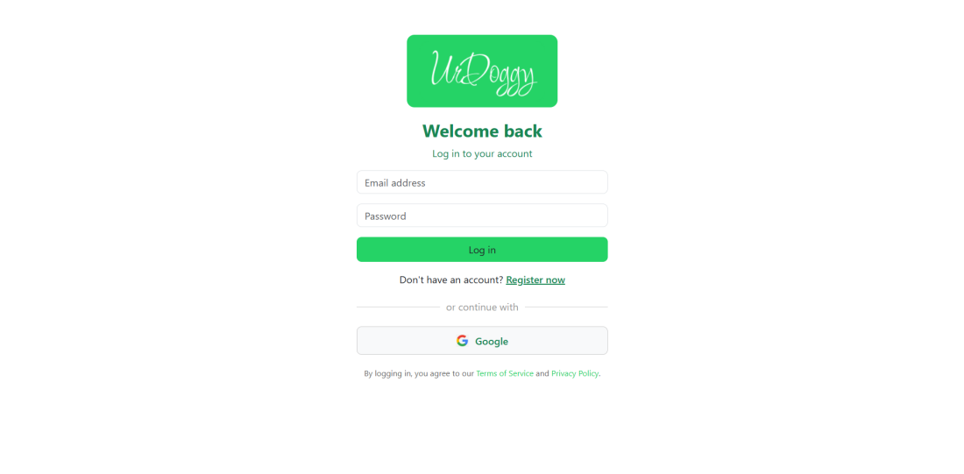
- Login page
This page will appear whenever open the app or register successfully or log out.
User need to fill up email and password and click on “Log in” button to login.
Or user can choose log in with google. If user not have account yet. User can click on “Register now” right below “Log in” button to register.

3.1.2. Register feature
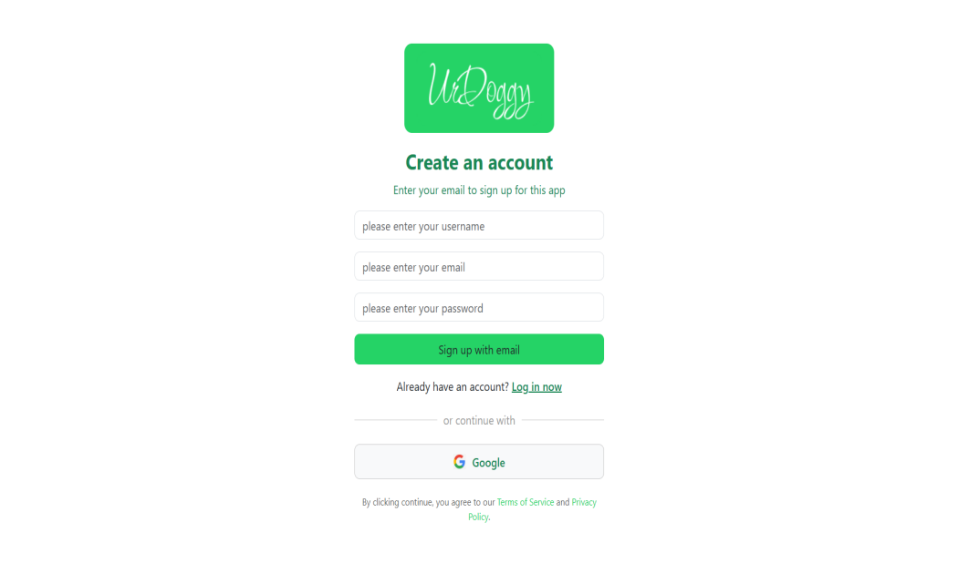
- Register page.
This page will appear when user don’t have an account yet and choose to register.
User need to fill up username, email and password and click on “Sign up with email” button to register. Or user can choose sign up with google. After user register, the app will redirect to login page. If user already have account. User can click on “Log in now” right below “Sign up with email” button to login.

3.2. Main page / Homepage

3.2.1. Newsfeed
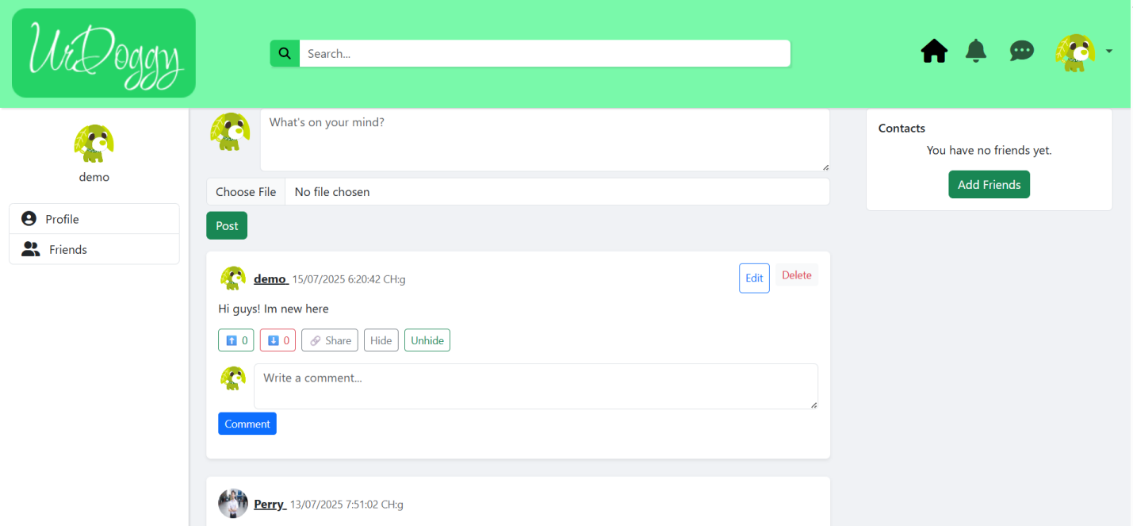
- Newsfeed
In homepage, it will have 4 sessions: topbar, left sidebar, right sidebar and main session view (middle session).
- Topbar
With topbar, UrDoggy’s logo appear on the top left corner, this logo also work like a button to homepage/reload the newsfeed page; in the middle of topbar is search bar; right next to it are, home button (house icon), notification button (bell icon), message button (comment dot icon); dropdown menu with user’s avatar, when extend it will contains profile button and log out button.

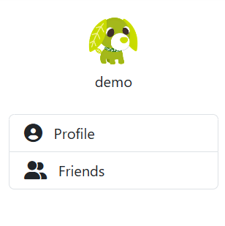  - General user’s left sidebar | 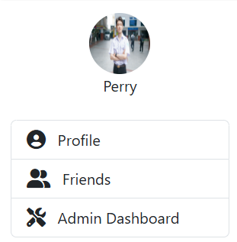  - Admin’s left sidebar

Left sidebar have user’s avatar and username, profile button and friends button (if user is admin, dashboard button will include in this session).
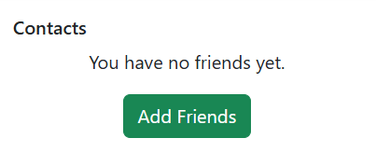
- Right sidebar when user don’t have friend yet
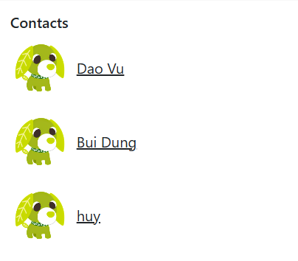
- Right sidebar when user have friend(s)
Right sidebar (Contacts session) will have two stage: first, when user don’t have any friends, right sidebar will have “Add friends” button and when click it will redirect to friends page; second, when user already have friends, it will show user’s friends with avatar and name. In the middle session, first is create new post session, then every posts display

3.2.2. Create post
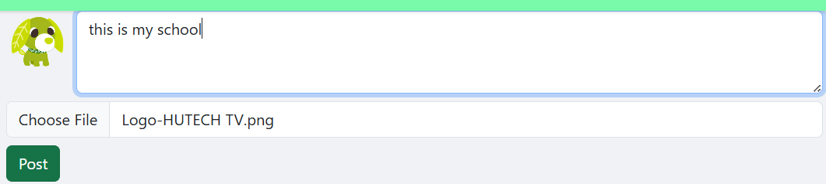
- Creating new post with image Url
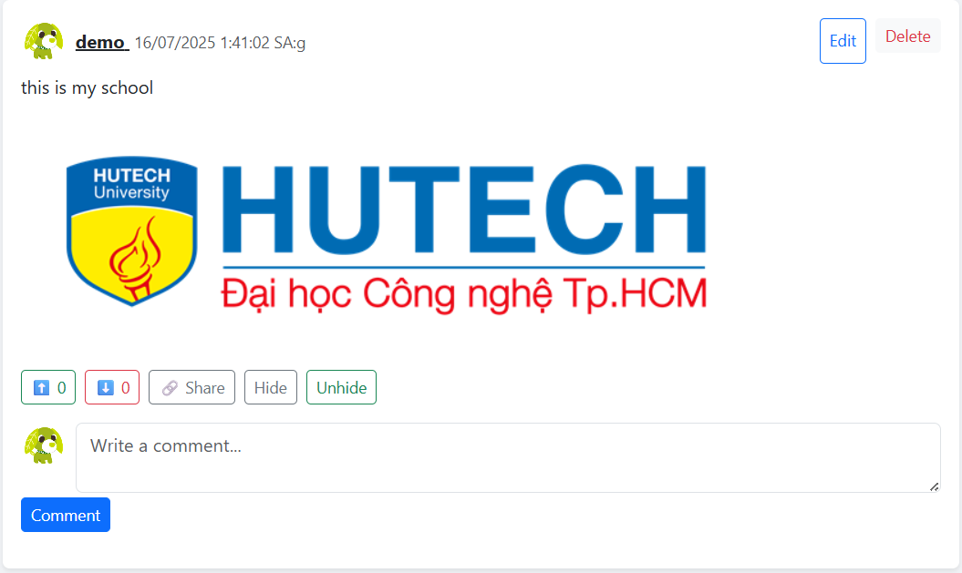
- After click post
User create posts via form at the top of the feed.

3.2.3. Post edit/delete
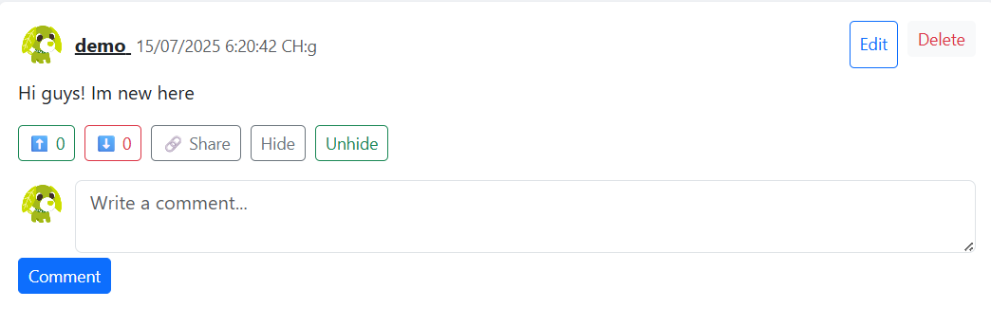
- Post view if user’s post
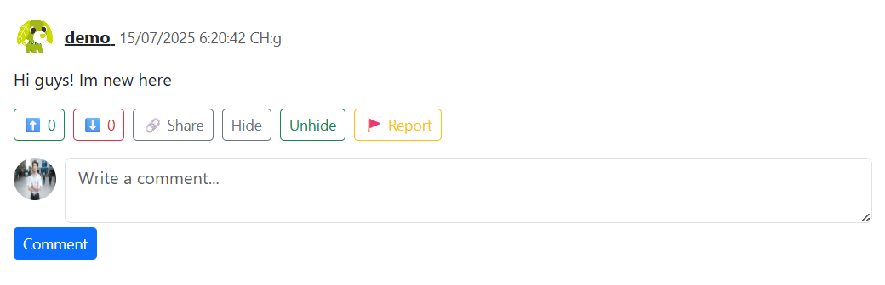
- Post view from other users

View own posts or from other users. User can: Vote on posts (upvote/downvote). Share link via clipboard. Hide/unhide posts for personal feed customization. Report inappropriate content. Edit or remove your own posts directly from the feed.

3.3. Post interact

3.3.1. Voting feature

- Up / down vote
If user see the post positive or negative, user can choose to vote.
3.2. Commenting feature

- Comment box on each post
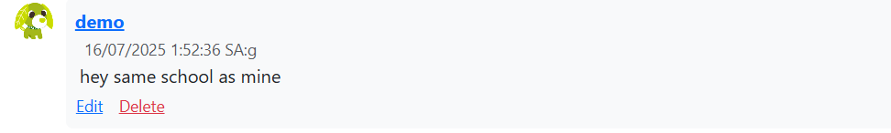
- After comment
User can leave comment on any post.

3.3.3. Edit / delete comment
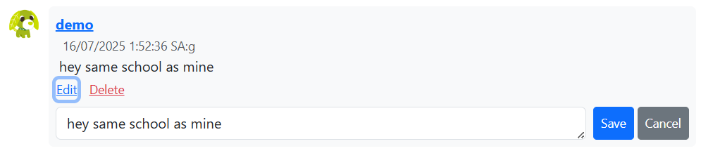
- When user want to edit or delete.
Edit or remove your own comment directly from the feed.

3.4. Sharing feature

- Share button
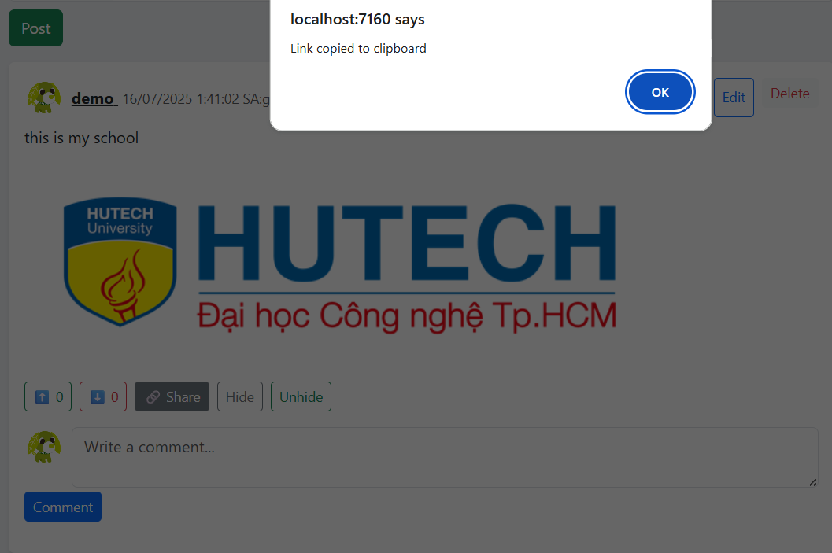
- After click share button
User can share any posts by click share button, and url link will being copy to clipboard.

3.5. Report feature

- Report button
Click report button if user feels that violates guidelines or feels inappropriate.

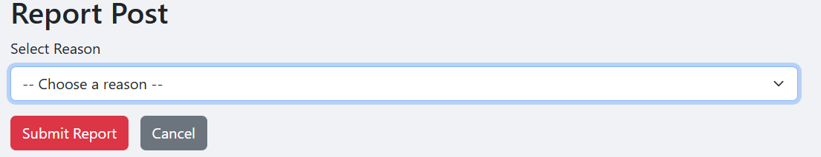
- Report form (Allows moderation without admin access.)

3.6. Hide / unhide post feature

- Hide and unhide button

3.6.1. Hide post
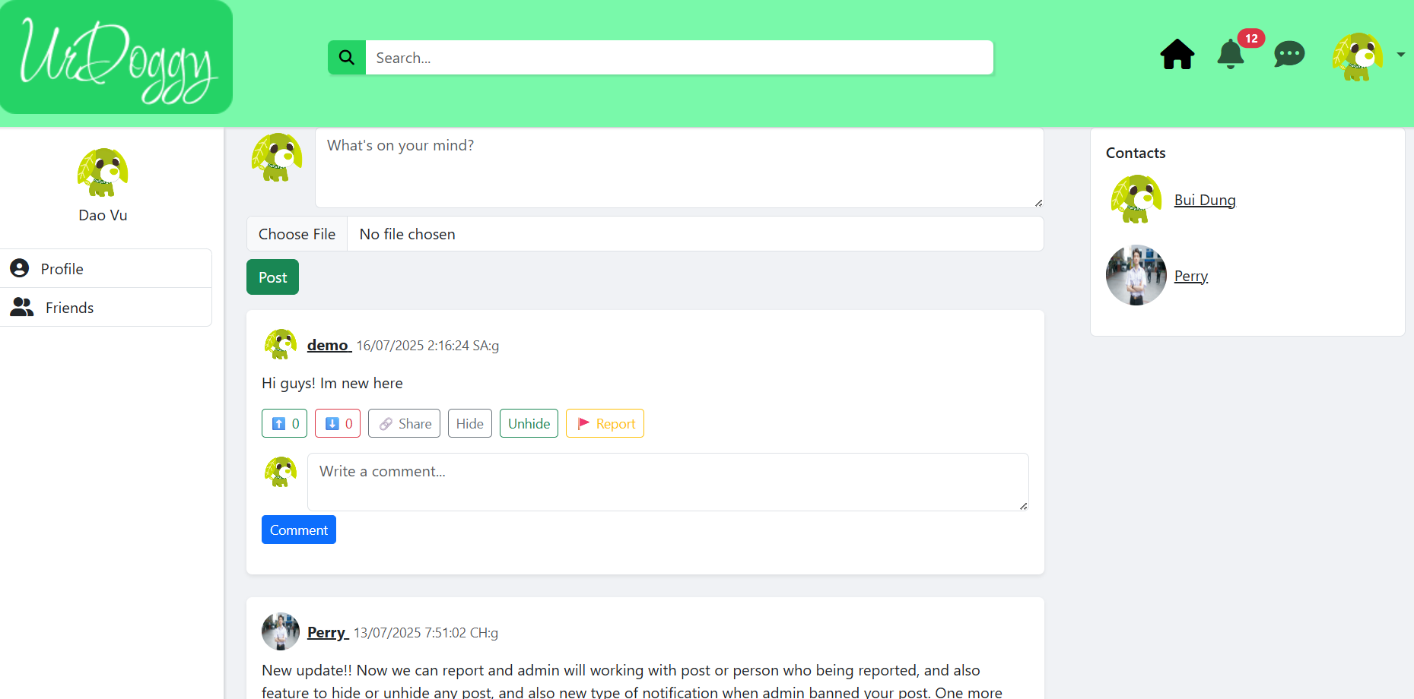
- Before hide post
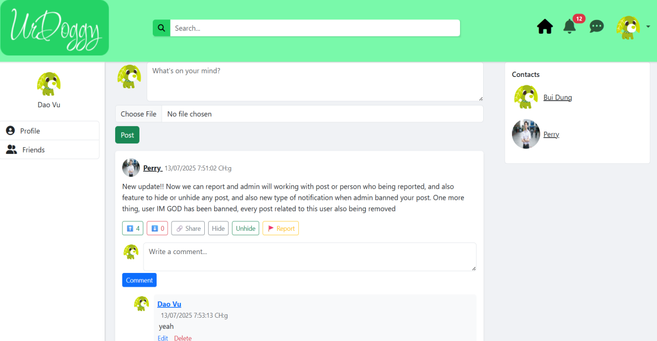
- Post now being hidden
Customize your feed by removing unwanted posts temporarily.

3.6.2. Unhide post
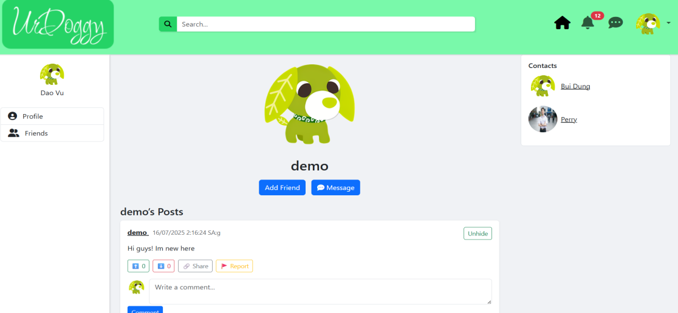
- Unhide post from user’s profile

- After unhide post
To unhide post, need to search for user who posted the post and select “Unhide” button to unhide the post.

3..7. Profile and Friends

3.7.1. View profile
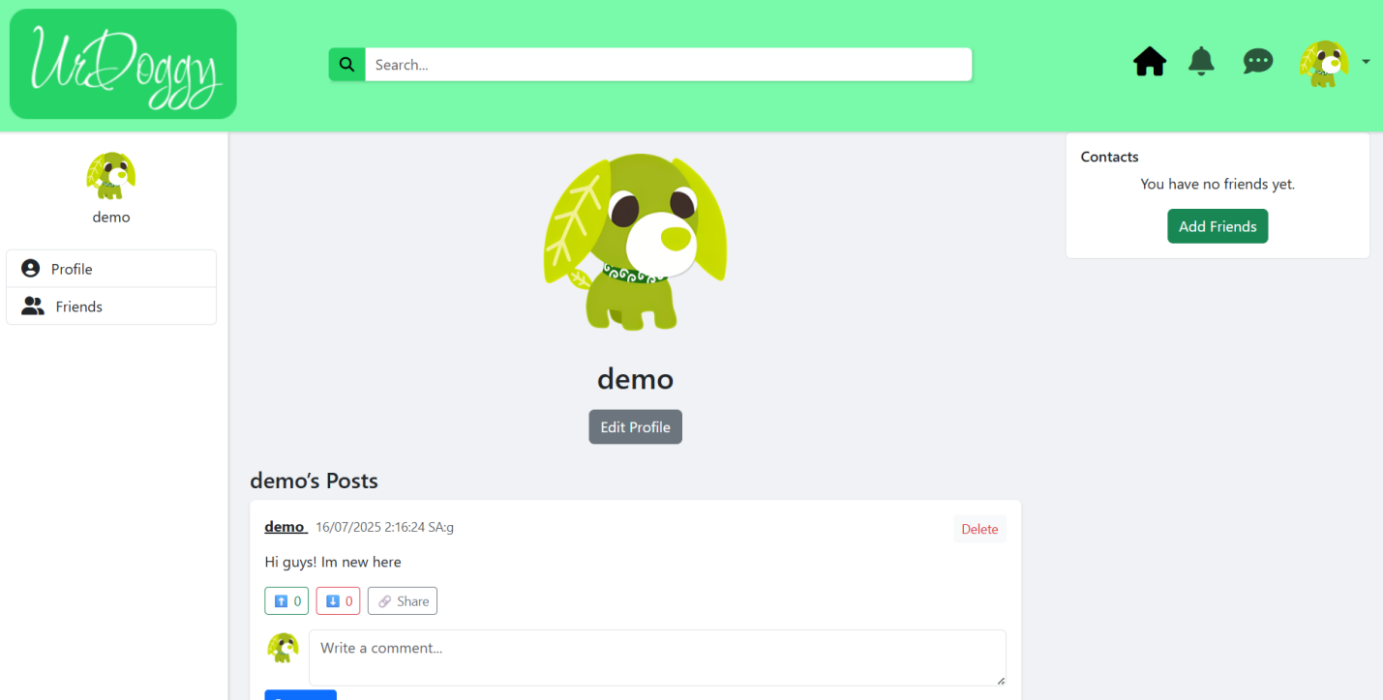
- Own user’s profile
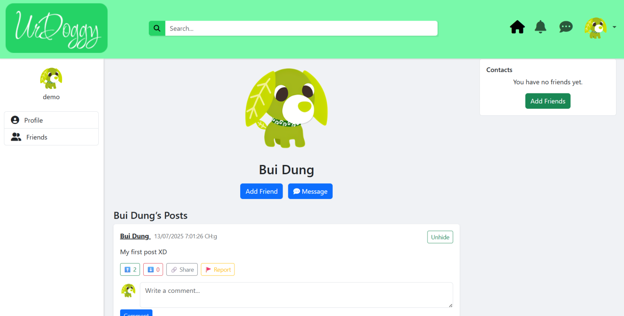
- Other’s profile

3.7.2. Edit profile
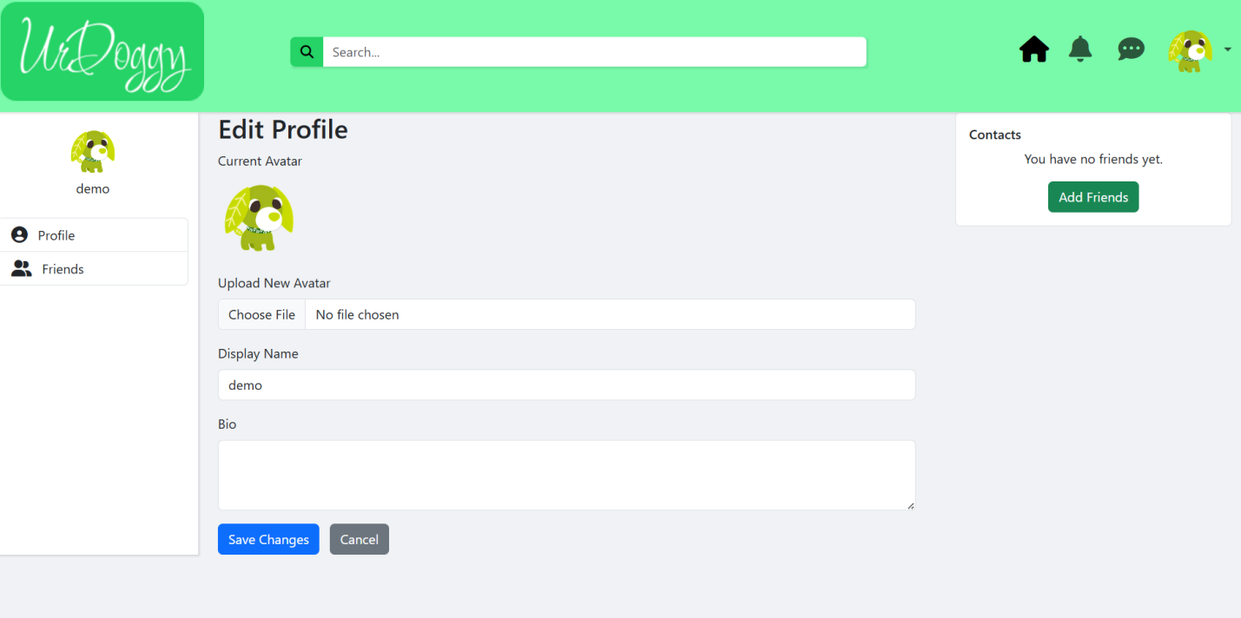
- Edit profile form
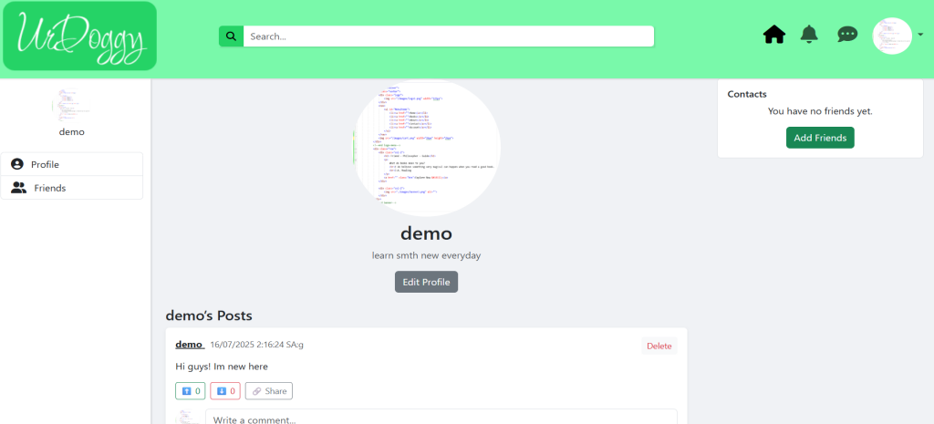
- After changed avatar and bio.

3.7.3. Friend actions
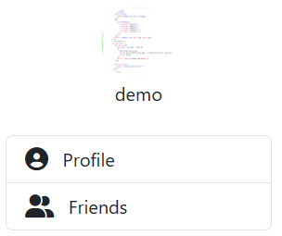  - “Friends” button on left sidebar | 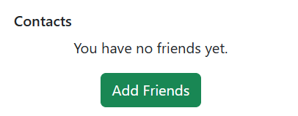  - “Add friends” button on right side bar

These are main 2 ways to get into friend management page.
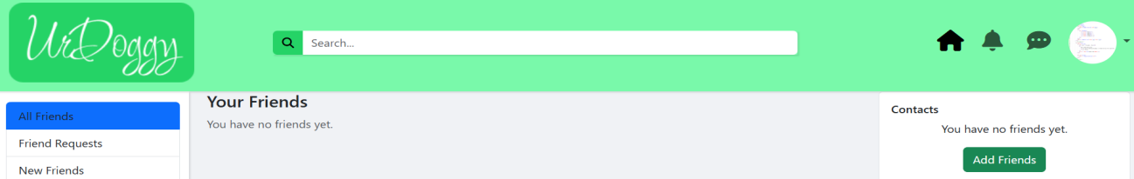
- If user have no friend yet
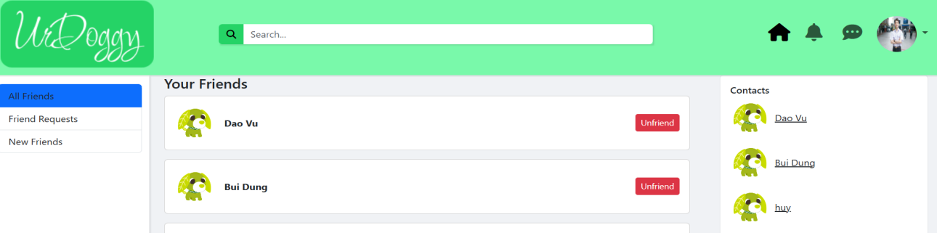
- If user have friend
This “All Friends” session display your current friends
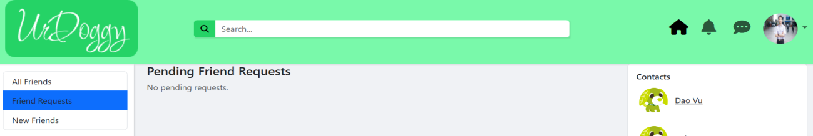
- When have no another user request
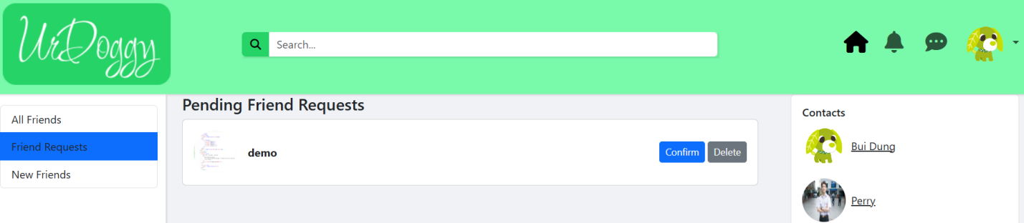
- When have another user request
This “Friend Requests” session display all pending request.
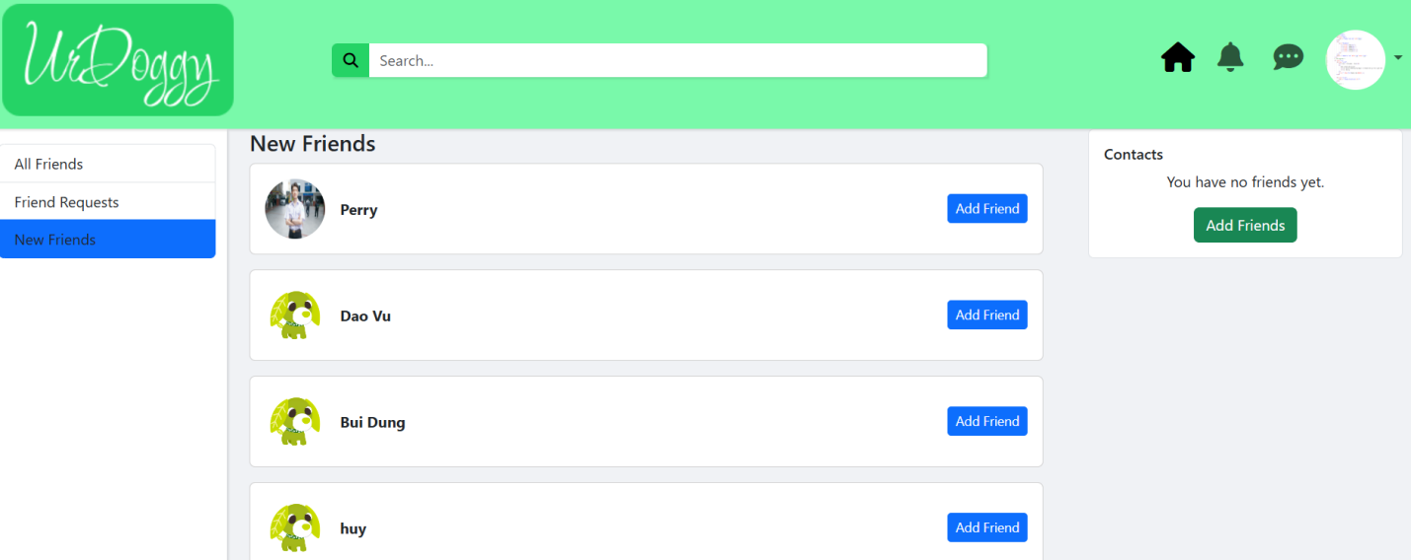
- New Friends session
This “New Friends” session let user add friends to make new friend.

3.8. Search feature
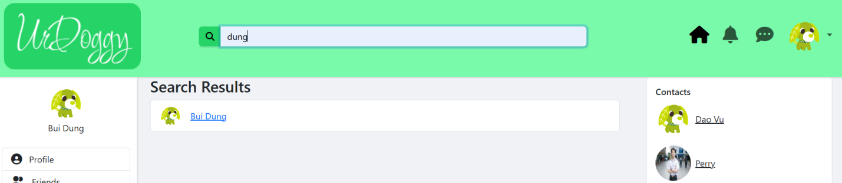
- If user search for themself
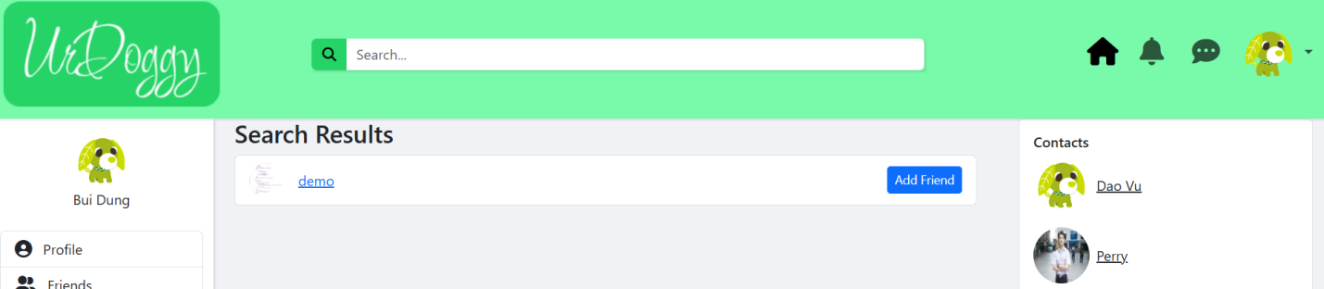
- If user search for others
When user search for themself, “Add Friend” button will not show up.
When user search for others, “Add Friend” button will show up.

3.9. Messaging

- Message button on navbar
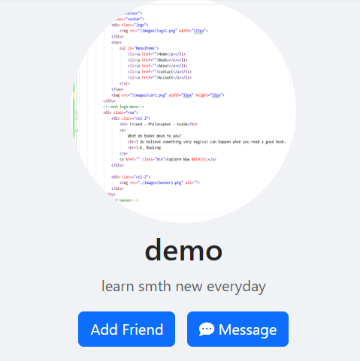
- Message button on other user’s profile
User can choose to texting when already add friend by click on message button on navbar or for quick message without add friend by click on message button on user’s profile, which other user want texting.
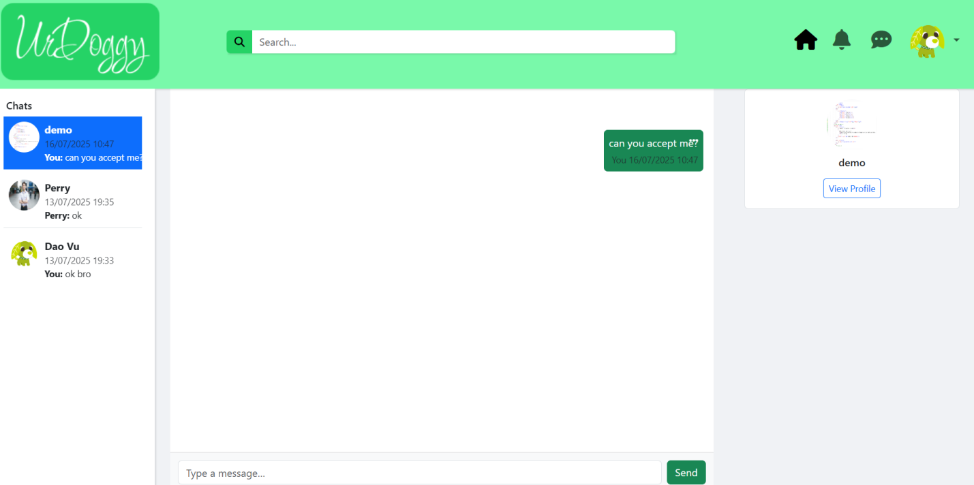
- Message page
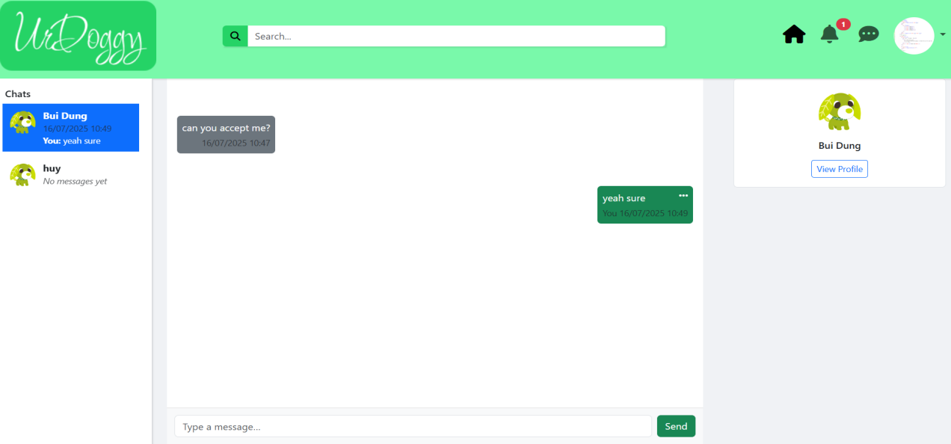
- Message page when other reply

3.10. Notification

 | 
- Bell icon - notification button
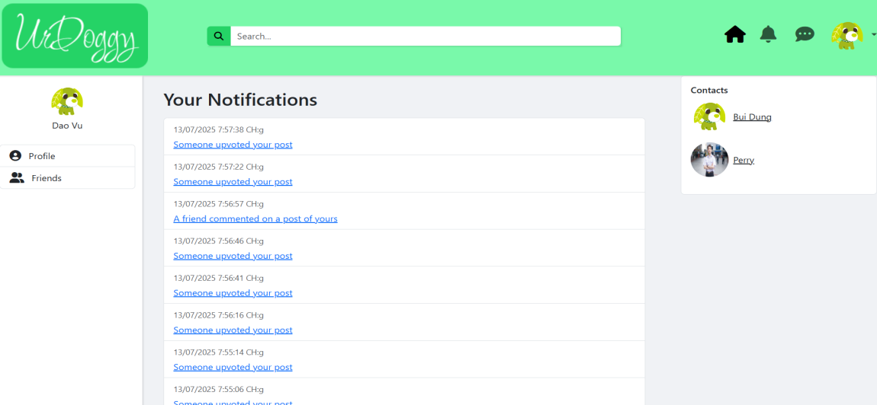
- Notification page
Quick and fast way to view to notifications and access to post or message that have notified.

3.11. Admin dashboard
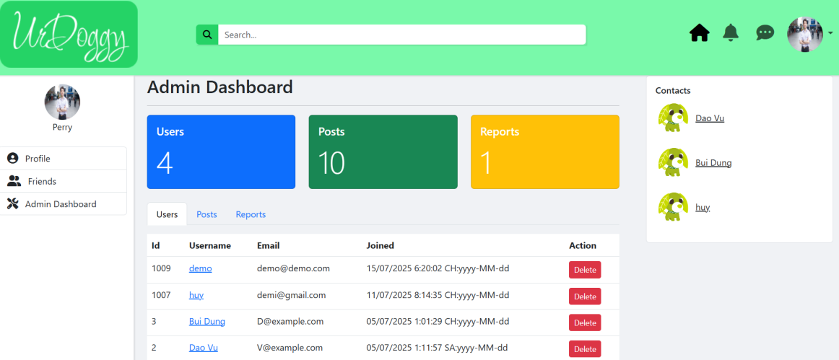
- Admin dashboard display all users
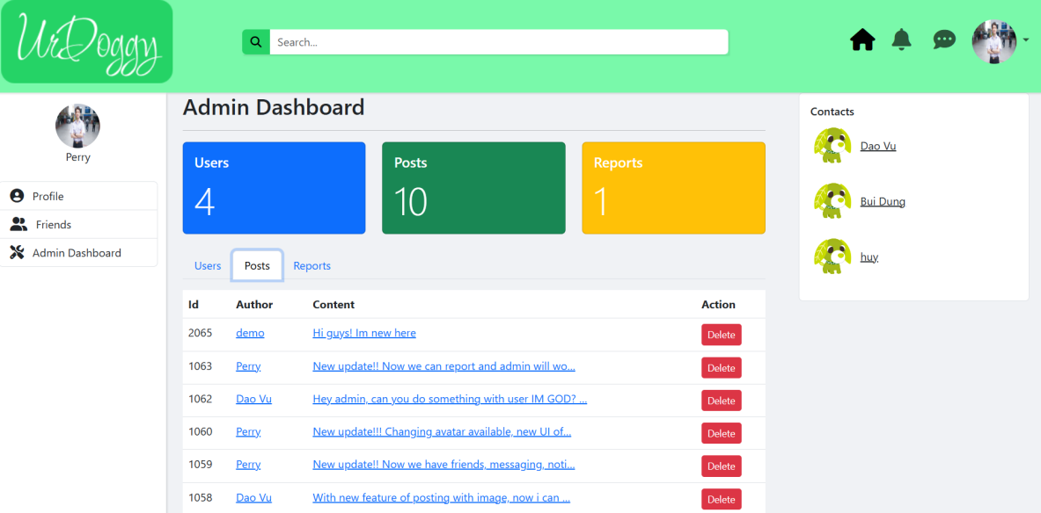
- Admin dashboard display all post
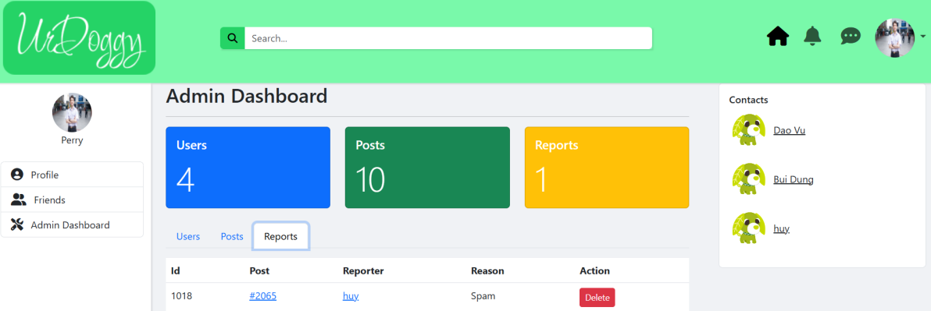
- Admin dashboard display all report
With all visible informations admin can easily see each user’s profiles, posts, reposts that link to posts to take actions against violation posts or users.

Chapter 4: Conclusion and Recommendations

4.1. Conclusion
The project has successfully achieved the goal of building an UrDoggy social networking platform. During the implementation process, the project has effectively used the fundamental theories of Layer Architecture, M.V.C (Model-View-Controller) model, along with the ASP.NET development platform. The successful application of Layer Architecture has helped the project to have the ability to manage modules, be easy to maintain, and the ability to expand the project development later. In addition, M.V.C Model has been used flexibly to help the project completely separate the processing logic, website interface, and data processing. From the above successes, a simple source code structure has been successfully created, is easy to maintain, and upgrade.
In practice, this project has successfully created a basic social networking platform with all the necessary features of a social networking application, such as user management, friend relationships, displaying posts and comments, and messaging. The biggest contribution of this project is to provide an overview of the process of developing an application, how to apply the fundamental theories to a real project, and handle possible cases when doing a real project. Besides the above successes, the project still has some limitations, such as not being optimized for performance, not having advanced features such as real-time messaging, and article recommendations.

4.2 New proposals and recommendations
In order for the UrDoggy social networking platform website to develop more and serve users better. We would like to suggest the next development direction. First, in terms of features, add real-time messaging, online, create groups, and suggest suitable articles. Next in terms of technology, improve, add a database to better suit the application, enhance security features, and store data on cloud computing. The recommendation is to continue developing the website application with advanced tools and platforms and do more practical projects to gain more experience, knowledge, and skills.

REFERENCES
[0] https://viblo.asia/p/tat-tan-tat-ve-mo-hinh-mvc-Rk74avjAJeO
[1] https://viblo.asia/p/layered-architecture-kien-truc-quoc-dan-zXRJ8OPw4Gq
[2] https://bkhost.vn/blog/asp-net/
[3] https://bizflycloud.vn/tin-tuc/tong-quan-ve-sql-server-management-studio-ssms-2020092515234411.htm
[4] https://viblo.asia/p/staruml-cai-dat-va-trai-nghiem-4P856dn1ZY3
[5] https://topdev.vn/blog/sql-server-la-gi/

